Interlace Mode Setting on Android S

目录
Android S original mode set flow 1
Android S new mode set flow 1
New interface 2
Real Mode 4
Self test 4

Android S original mode set flow
As we know that, we must use google’s standard framework interface to set display mode. And it does not support interlace mode.
Our (old) mode set flow for Android S is shown in Fig.1
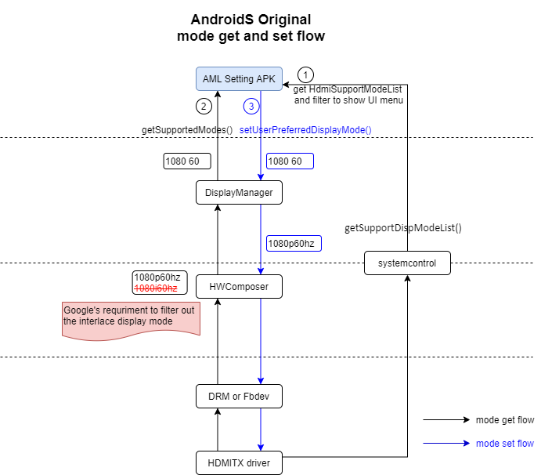
Fig.1 Old mode set flow for Android S

This flow is based on AML Setting APK.
- APK get HDMI supported modes list and filter it to show UI menu
- APK getSupportedModes through google’s standard framework interface.
- APK set display mode through google’s standard framework interface.
The flow of ① is legacy of Android R, and we’re still using it.
Due to Google’s framework does not support interlace mode, so our hwcomposer filter out interlace modes and reports progressive mode list to framework.

Android S new mode set flow
The new mode set flow is shown as Fig.2
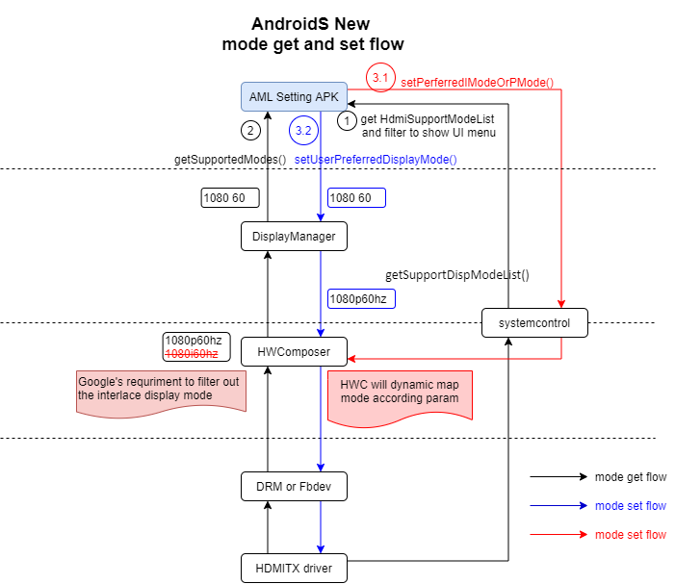
Fig.2 New mode set flow for Android S

This flow is based on AML Setting APK. (SKB need modify SKB’s setting logic to set interlace mode. AML settting only for test and can not be modified because it may affect xTS. )
- APK get HDMI supported modes list and filter it to show UI menu
- APK getSupportedModes through google’s standard framework interface.
- APK set display mode through AML private API and google’s standard framework interface.
  - Call setPerferredIModeOrPMode() when Progressive and Interlace mode switch.
  - Call setUserPreferredDisplayMode() to set display mode.

New interface
To support interlace mode setting, we add new private interface.
【File】
vendor/amlogic/common/frameworks/core/java/com/droidlogic/app/SystemControlManager.java
【API】
public void setPerferredIModeOrPMode(String mode, boolean isInterlace);
【Param】
Name | Description | Input/Output
mode | Display mode string, such as “1080i60hz” | Input
isInterlace | The mode is interlace or not. | Input

【Instruction】
- P <-> I
  - Call setPerferredIModeOrPMode to set mode and interlace flag to Hwcomposer.
  - Then call google standard framework interface to set display mode.
- P <-> P or I <-> I
  - Call google standard framework interface to set display mode directly.

【Reference code】
Setting APK code path:
vendor/amlogic/common/apps/DroidTvSettings/src/com/droidlogic/tv/settings/display/outputmode/
public boolean onPreferenceTreeClick(Preference preference) {
if (preference instanceof RadioPreference) {
final RadioPreference radioPreference = (RadioPreference) preference;
radioPreference.clearOtherRadioPreferences(getPreferenceScreen());
if (radioPreference.isChecked()) {
preMode = mOutputUiManager.getCurrentMode().trim();
curMode = radioPreference.getKey();
curPreference = radioPreference;
Log.d(LOG_TAG, "currentMode: " + preMode + "; NextMode: " + curMode);

boolean interlace = false;
if (!preMode.contains("i") && curMode.contains("i")) {
interlace = true;
Log.i(LOG_TAG, "P -> I, set mode to: " + curMode + "; interlace: " + interlace);
mOutputUiManager.setPerferredIModeOrPMode(curMode, interlace);
} else if (preMode.contains("i") && !curMode.contains("i")) {
interlace = false;
Log.i(LOG_TAG, "I -> P, set mode to: " + curMode + "; interlace: " + interlace);
mOutputUiManager.setPerferredIModeOrPMode(curMode, interlace);
}
mOutputUiManager.change2NewMode(curMode);
// showDialog();
curPreference.setChecked(true);
} else {
radioPreference.setChecked(true);
}
}
return super.onPreferenceTreeClick(preference);
}

Real Mode
We should enable RealMode for this feature.
BoardConfig.mk
HWC_ENABLE_REAL_MODE := true
HWC_HDMI_FRAC_MODE := 2

Self test
We can test it with AML Setting APK after apply related patches.
su
am start -a android.settings.SETTINGS
Note: The patch of setting APK is only used for test, and do not merge it.

Mode switch
Mode switch | Src Mode | Des Mode | Result | Comment
P -> I | 1080p60 | 1080i60 | Pass
 | 1080p60 | 1080i50 | Pass
 | 720p60 | 1080i60 | Pass
 | 720p60 | 1080i50 | Pass
I -> P | 1080i60 | 1080p60 | Pass
 | 1080i60 | 1080p50 | Pass
 | 1080i50 | 1080p50 | Pass
 | 1080i50 | 1080p60 | Pass
 | 1080i50 | 720p60 | Pass
P -> P | 1080p60 | 1080p50 | Pass
 | 1080p50 | 1080p60 | Pass
 | 1080p60 | 720p60 | Pass
 | 720p60 | 1080p60 | Pass
I -> I | 1080i60 | 1080i50 | Pass
 | 1080i50 | 1080i60 | Pass

Suspend/resume
Cases | Result | Comment
Hotplug after set interlace mode, then check display mode | Pass
Hotplug after set interlace mode, then switch mode | Pass
Standby and wakeup after set interlace mode | Pass

